https://www.youtube.com/watch?v=cB-jlc6aWXA Azure Front Door
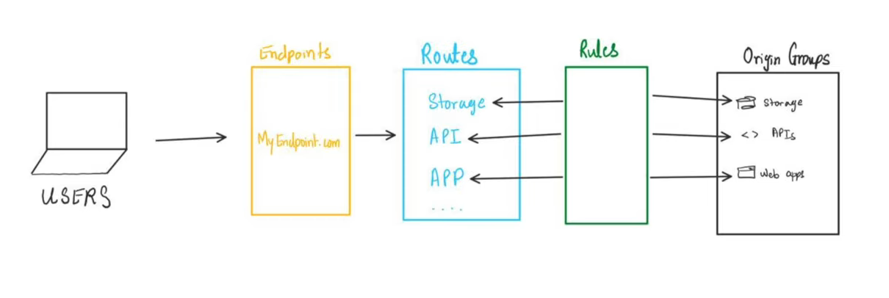
https://www.youtube.com/watch?v=jq_LZ1RFPfU
Five Security Principles
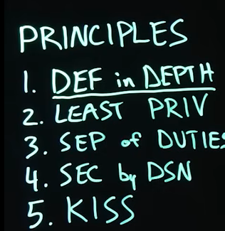
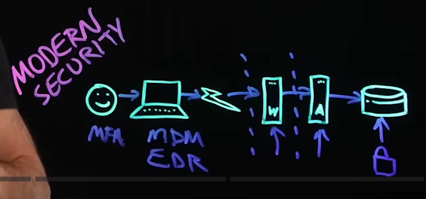
Defence In Depth Security
Least Privileges
Separatnion of duties
Secure by design (start to finish) (from requirements phase to prod)
Keep it simple stupid (KISS)

Secret is not secure

